Chapter 2. Enhancing Your Blog and Adding Social Features

In the preceding chapter, we learned the main components of Django by developing a simple blog application using views, templates, and URLs. In this chapter, we will extend the functionalities of the blog application with features that can be found in many blogging platforms nowadays.

In this chapter, you will learn the following topics:
- Using canonical URLs for models
- Creating SEO-friendly URLs for posts
- Adding pagination to the post list view
- Building class-based views
- Sending emails with Django
- Using Django forms to share posts via email
- Adding comments to posts using forms from models

Functional overview
Figure 2.1 shows a representation of the views, templates, and functionalities that will be built in this chapter:
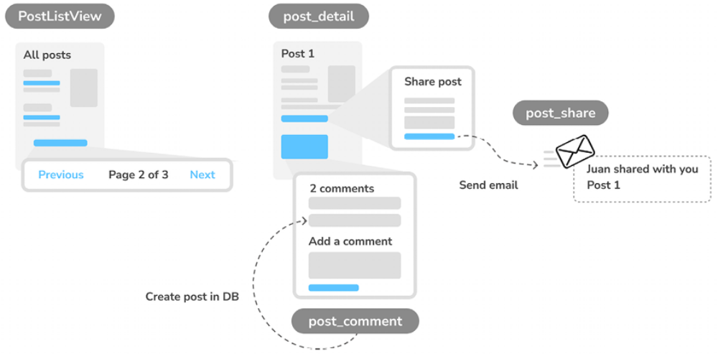
Figure 2.1: Diagram of functionalities built in Chapter 2
In this chapter, we will add pagination to the post list page to navigate through all posts. We will also learn how to build class-based views with Django and convert the post_list view to a class-based view named PostListView .

We will create the post_share view to share posts via email. We will use Django forms to share posts and send email recommendations via Simple Mail Transfer Protocol (SMTP). To add comments to posts, we will create a Comment model to store comments, and we will build the post_comment view using forms for models.

The source code for this chapter can be found at
https://github.com/PacktPublishing/Django-5-byexample/tree/main/Chapter02.

All Python packages used in this chapter are included in the requirements.txt file in the source code for the chapter. You can follow the instructions to install each Python package in the following sections, or you can install all the requirements at once with the python -m pip install -r requirements.txt command.

Using canonical URLs for models
A website might have different pages that display the same content. In our application, the initial part of the content for each post is displayed both on the post list page and the post detail page. A canonical URL is the preferred URL for a resource. You can think of it as the URL of the most representative page for specific content. There might be different pages on your site that display posts, but there is a single URL that you use as the main URL for a post.

Canonical URLs allow you to specify the URL for the master copy of a page. Django allows you to implement the get_absolute_url() method in your models to return the canonical URL for the object.

We will use the post_detail URL defined in the URL patterns of the application to build the canonical URL for Post objects. Django provides different URL resolver functions that allow you to build URLs dynamically using their name and any required parameters. We will use the reverse() utility function of the django.urls module.

Edit the models.py file of the blog application to import the reverse() function and add the get_absolute_url() method to the Post model as follows. The new code is highlighted in bold:
from django.conf import settings
from django.db import models
from django.urls import reverse
from django.utils import timezone
# Create your models here.
class PublishedManager(models.Manager):
def get_queryset(self):
return(
super().get_queryset().filter(status=Post.Status.PUBLISHED)
)

class Post(models.Model):
# …
class Meta:
ordering = ['-publish']
indexes = [
models.Index(fields=['publish']),
]
def __str__(self):
return self.title

def get_absolute_url(self):
return reverse(
'blog:post_detail', args=[self.id]
)

The reverse() function will build the URL dynamically using the URL name defined in the URL patterns. We have used the blog namespace followed by a colon and the post_detail URL name. Remember that the blog namespace is defined in the main urls.py file of the project when including the URL patterns from blog.urls . The post_detail URL is defined in the urls.py file of the blog application.

The resulting string, blog:post_detail , can be used globally in your project to refer to the post detail URL. This URL has a required parameter, which is the id of the blog post to retrieve. We have included the id of the Post object as a positional argument by using args=[self.id] . You can learn more about the URL’s utility functions at
https://docs.djangoproject.com/en/5.0/ref/urlresolvers/.

Let’s replace the post detail URLs in the templates with the new get_absolute_url() method.
Edit the blog/post/list.html file and replace the following line:
<a href="{% url 'blog:post_detail' post.id %}">

Replace the preceding line with the following line:
<a href="{{ post.get_absolute_url }}">

The blog/post/list.html file should now look as follows:
{% extends "blog/base.html" %}
{% block title %}My Blog{% endblock %}
{% block content %}
<h1>My Blog</h1>
{% for post in posts %}
<h2>
<a href="{{ post.get_absolute_url }}">
{{ post.title }}
</a>
</h2>
<p class="date">
Published {{ post.publish }} by {{ post.author }}
</p>
{{ post.body|truncatewords:30|linebreaks }}
{% endfor %}
{% endblock %}

Open the shell prompt and execute the following command to start the development server:
python manage.py runserver

Open http://127.0.0.1:8000/blog/ in your browser. Links to individual blog posts should still work. Django now builds the post URLs using the get_absolute_url() method of the Post model.

Creating SEO-friendly URLs for posts
The canonical URL for a blog post detail view currently looks like /blog/1/ . We will change the URL pattern to create SEO-friendly URLs for posts. We will be using both the publish date and slug values to build the URLs for single posts. By combining dates, we will make a post detail URL to look like /blog/2024/1/1/who-was-django-reinhardt/ . We will provide search engines with friendly URLs to index, containing both the title and date of the post.

To retrieve single posts with the combination of publication date and slug, we need to ensure that no post can be stored in the database with the same slug and publish date as an existing post. We will prevent the Post model from storing duplicated posts by defining slugs to be unique for the publication date of the post.

Edit the models.py file and add the following unique_for_date parameter to
the slug field of the Post model:
# …
title = models.CharField(max_length=250,
unique_for_date='publish')
# …

By using unique_for_date , the slug field is now required to be unique for the date stored in the publish field. Note that the publish field is an instance of DateTimeField , but the check for unique values will be done only against the date (not the time). Django will prevent you from saving a new post with the same slug as an existing post for a given publication date. We have now ensured that slugs are unique for the publication date, so we can now retrieve single posts by the publish and slug fields.

We have changed our models, so, let’s create migrations. Note that unique_for_date is not enforced at the database level, so no database migration is required. However, Django uses migrations to keep track of all model changes. We will create a migration just to keep migrations aligned with the current state of the model.

Run the following command in the shell prompt:
python manage.py makemigrations blog

You should get the following output:
Migrations for 'blog':
blog/migrations/0002_alter_post_slug.py
- Alter field slug on post

Django just created the 0002_alter_post_slug.py file inside the migrations directory of the blog application.
Execute the following command in the shell prompt to apply existing migrations:
python manage.py migrate

You will get an output that ends with the following line:
Applying blog.0002_alter_post_slug... OK

Django will consider that all migrations have been applied and the models are in sync. No action will be done in the database because unique_for_date is not enforced at the database level.

Modifying the URL patterns
Let’s modify the URL patterns to use the publication date and slug for the
post detail URL.

Edit the urls.py file of the blog application and replace the following line:
path('<int:id>/', views.post_detail, name='post_detail'),

Replace the preceding line with the following lines:
path(
'<int:year>/<int:month>/<int:day>/<slug:post>/',
views.post_detail,
name='post_detail'
),

The urls.py file should now look like this:
from django.urls import path
from . import views
app_name = 'blog'
urlpatterns = [
path('', views.post_list, name='post_list'),
path('<int:year>/<int:month>/<int:day>/<slug:post>/',
views.post_detail, name='post_detail'),
]
The URL pattern for the post_detail view takes the following arguments:
- year : This requires an integer
- month : This requires an integer
- day : This requires an integer
- post : This requires a slug (a string that contains only letters, numbers, underscores, or hyphens)

The int path converter is used for the year , month , and day parameters, whereas the slug path converter is used for the post parameter. You learned about path converters in the previous chapter. You can see all path converters provided by Django at
https://docs.djangoproject.com/en/5.0/topics/http/urls/#path-converters.

Our posts have now an SEO-friendly URL that is built with the date and slug of each post. Let’s modify the post_detail view accordingly.

Modifying the views
We will change the parameters of the post_detail view to match the new URL parameters and use them to retrieve the corresponding Post object.

Edit the views.py file and edit the post_detail view like this:
def post_detail(request, year, month, day, post):
post = get_object_or_404(
Post,
status=Post.Status.PUBLISHED,
slug=post,
publish__year=year,
publish__month=month,
publish__day=day
)
return render(
request,
'blog/post/detail.html',
{'post':post}
)

We have modified the post_detail view to take the year , month , day , and post arguments and retrieve a published post with the given slug and publication date. By adding unique_for_date='publish' to the slug field of the Post model, we ensured that there would be only one post with a slug for a given date. Thus, you can retrieve single posts using the date and slug.

Modifying the canonical URL for posts
We also have to modify the parameters of the canonical URL for blog posts to match the new URL parameters.

Edit the models.py file of the blog application and edit the
get_absolute_url() method as follows:
class Post(models.Model):
# …
def get_absolute_url(self):
return reverse(
'blog:post_detail',
args = [
self.publish.year,
self.publish.month,
self.publish.day,
self.slug
]
)

Start the development server by typing the following command in the shell
prompt:
python manage.py runserver

Next, you can return to your browser and click on one of the post titles to take a look at the detail view of the post. You should see something like this:
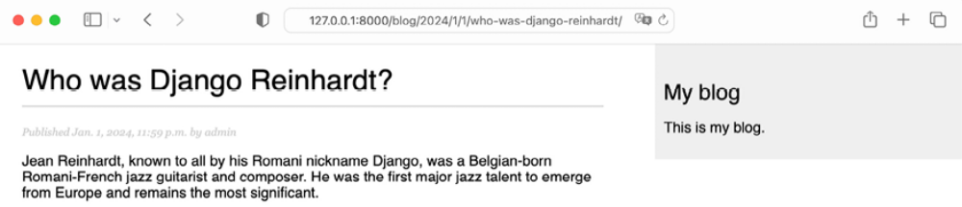
Figure 2.2: The page for the post’s detail view

You have designed SEO-friendly URLs for the blog posts. The URL for a post now looks like /blog/2024/1/1/who-was-django-reinhardt/ .

Now that you have implemented SEO-friendly URLs, let’s focus on implementing navigation through posts using pagination.

Adding pagination
When you start adding content to your blog, you can easily store tens or hundreds of posts in your database. Instead of displaying all the posts on a single page, you may want to split the list of posts across several pages and include navigation links to the different pages. This functionality is called pagination, and you can find it in almost every web application that displays long lists of items.

For example, Google uses pagination to divide search results across multiple
pages. Figure 2.3 shows Google’s pagination links for search result pages:

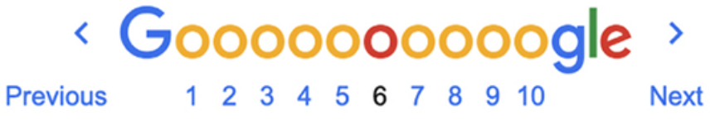
Figure 2.3: Google pagination links for search result pages

Django has a built-in pagination class that allows you to manage paginated data easily. You can define the number of objects you want to be returned per page and you can retrieve the posts that correspond to the page requested by the user.

Adding pagination to the post list view
We will add pagination to the list of posts so that users can easily navigate through all posts published on the blog.

Edit the views.py file of the blog application to import the Django Paginator class and modify the post_list view as follows:
from django.core.paginator import Paginator
from django.shortcuts import get_object_or_404, render
from .models import Post
def post_list(request):
post_list=Post.published.all()
# Pagination with 3 posts per page
Paginator = Paginator(post_list, 3)
page_number = request.GET.get('page', 1)
posts = paginator.page(page_number)
return render(
request,
'blog/post/list.html',
{'posts':posts}
)

Let’s review the new code we have added to the view:
1. We instantiate the Paginator class with the number of objects to return per page. We will display three posts per page.
2. We retrieve the page GET HTTP parameter and store it in the page_number variable. This parameter contains the requested page number. If the page parameter is not in the GET parameters of the request, we use the default value 1 to load the first page of results.

3. We obtain the objects for the desired page by calling the page() method of Paginator . This method returns a Page object that we store in the posts variable.

4. We pass the posts object to the template.

Creating a pagination template
We need to create a page navigation for users to browse through the different pages. In this section, we will create a template to display the pagination links, and we’ll make it generic so that we can reuse the template for any object pagination on our website.
In the templates/ directory, create a new file and name it pagination.html . Add the following HTML code to the file:
<div class="pagination">
<span class="step-link">
{% if page.has_previous %}
<a href="?page={{ page.previous_page_number }}">Previous</a>
{% endif %}
<span class="current">
Page {{ page_number}} of {{ page.paginator.num_pages}}.
</span>
{% if page.has_next %}
<a href="?page={{ page.next_page_number }}">Next</a>
{% endif %}
</span>
</div>

This is the generic pagination template. The template expects to have a Page object in the context to render the previous and next links and to display the current page and total pages of results.

Let’s return to the blog/post/list.html template and include the pagination.html template at the bottom of the {% content %} block, as follows:
{% extends "blog/base.html" %}
{% block title %}My Blog{% endblock %}
{% block content %}
<h1>My Blog</h1>
{% for post in posts %}
<h2>
<a href="{{ post.get_absolute_url }}">
{{ post.title }}
</a>
</h2>
<p class="date">
Published {{ post.publish }} by {{ post.author }}
</p>
{{ post.body|truncatewords:30|linebreaks }}
{% endfor %}
{% include "pagination.html" with page=posts %}
{% endblock %}

The {% include %} template tag loads the given template and renders it using the current template context. We use with to pass additional context variables to the template. The pagination template uses the page variable to render, while the Page object that we pass from our view to the template is called posts . We use with page=posts to pass the variable expected by the pagination template. You can follow this method to use the pagination
template for any type of object.

Start the development server by typing the following command in the shell prompt:
python manage.py runserver

Open http://127.0.0.1:8000/admin/blog/post/ in your browser and use the administration site to create a total of four different posts. Make sure to set the status to Published for all of them.

Now, open http://127.0.0.1:8000/blog/ in your browser. You should see the first three posts in reverse chronological order, and then the navigation links at the bottom of the post list like this:
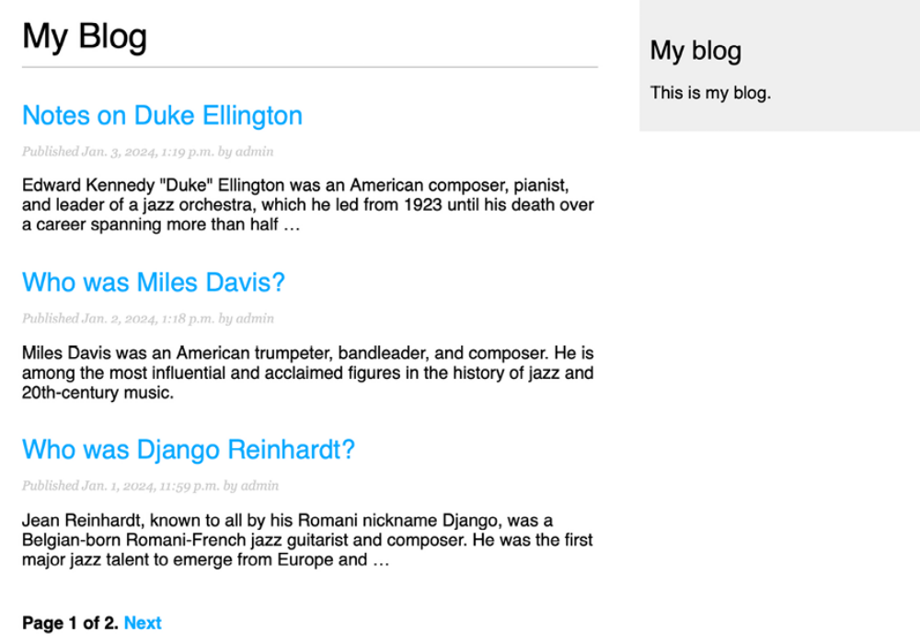
Figure 2.4: The post list page including pagination

If you click on Next, you will see the last post. The URL for the second page contains the ?page=2 GET parameter. This parameter is used by the view to load the requested page of results using the paginator.
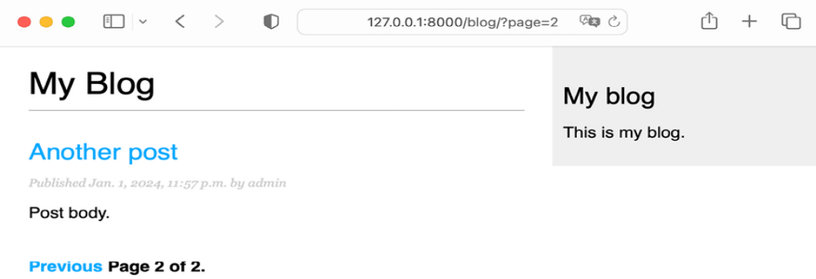
Figure 2.5: The second page of results
Great! The pagination links are working as expected.
Handling pagination errors
Now that the pagination is working, we can add exception handling for pagination errors in the view. The page parameter used by the view to retrieve the given page could potentially be used with wrong values, such as non-existing page numbers or a string value that cannot be used as a page number. We will implement appropriate error handling for those cases.

Open http://127.0.0.1:8000/blog/?page=3 in your browser. You should see the following error page:
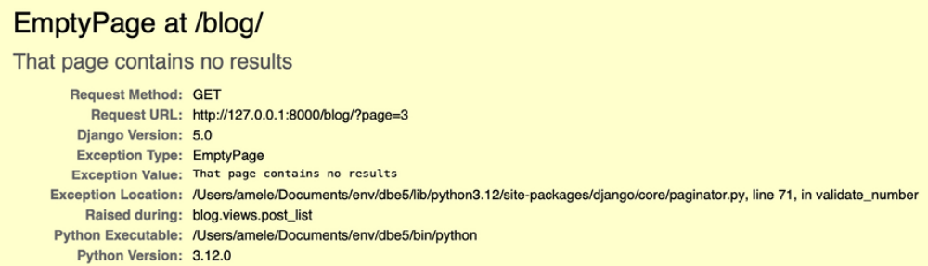
Figure 2.6: The EmptyPage error page

The Paginator object throws an EmptyPage exception when retrieving page 3 because it’s out of range. There are no results to display. Let’s handle this error in our view.

Edit the views.py file of the blog application to add the necessary imports and modify the post_list view as follows:
from django.core.paginator import EmptyPage, Paginator
from django.shortcuts import get_object_or_404, render

from .models import Post

def post_list(request, tag_slug=None):
post_list = Post.published.all()
tag = None
if tag_slug:
tag=get_object_or_404(Tag, slug=tag_slug)
post_list=post_list.filter(tags__in=[tag])
# Pagination with 3 posts per page
paginator = Paginator(post_list, 3)
page_number = request.GET.get('page', 1)
try:
posts = paginator.page(page_number)
except EmptyPage:
# If page_nember is out of range, get last page of results.
posts = paginator.page(paginator.num_pages)
return render(
request,
'blog/post/list.html',
{'posts':posts}
)
We have added a try and except block to manage the EmptyPage exception when retrieving a page. If the page requested is out of range, we return the last page of results. We get the total number of pages with paginator.num_pages . The total number of pages is the same as the last page number.

Open http://127.0.0.1:8000/blog/?page=3 in your browser again. Now, the exception is managed by the view, and the last page of results is returned as follows:
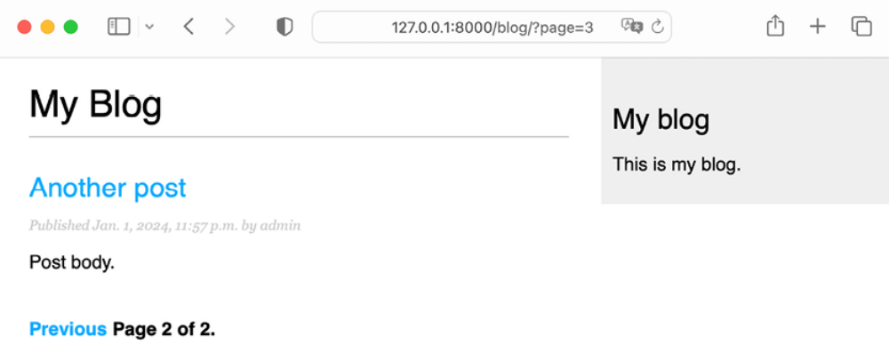
Figure 2.7: The last page of results

Our view should also handle the case when something different than an integer is passed in the page parameter.

Open http://127.0.0.1:8000/blog/?page=asdf in your browser. You should
see the following error page:
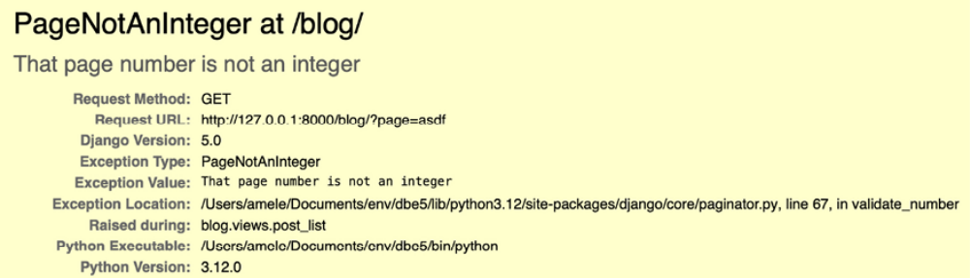
Figure 2.8: The PageNotAnInteger error page

In this case, the Paginator object throws a PageNotAnInteger exception when retrieving the page asdf because page numbers can only be integers. Let’s handle this error in our view.

Edit the views.py file of the blog application to add the necessary imports and modify the post_list view as follows:
from django.core.paginator import EmptyPage, Paginator
from django.shortcuts import get_object_or_404, render
from .models import Post
# Create your views here.
def post_list(request):
post_list = Post.published.all()
# Pagination with 3 posts per page
paginator = Paginator(post_list, 3)
page_number=request.GET.get('page', 1)
try:
posts = paginator.page(page_number)
except EmptyPage:
# If page_nember is out of range, get last page of results.
posts = paginator.page(paginator.num_pages)
return render(
request,
'blog/post/list.html',
{'posts':posts}
)

We have added a new except block to manage the PageNotAnInteger exception when retrieving a page. If the page requested is not an integer, we return the first page of results.

Open http://127.0.0.1:8000/blog/?page=asdf in your browser again.
Now, the exception is managed by the view and the first page of results is returned as follows:
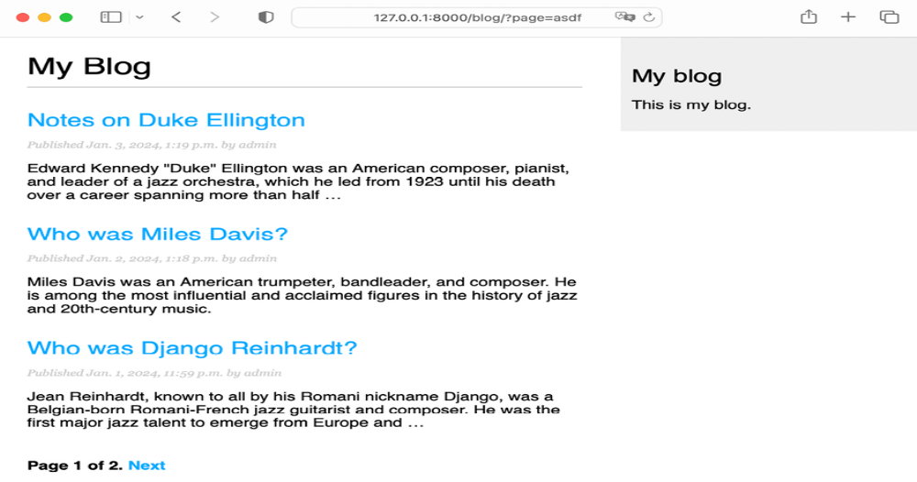
Figure 2.9: The first page of results

The pagination for blog posts is now fully implemented. You can learn more about the Paginator class at https://docs.djangoproject.com/en/5.0/ref/paginator/.

Having learned how to paginate your blog, we will now turn to transforming the post_list view into an equivalent view that is built using Django generic views and built-in pagination.

Building class-based views
We have built the blog application using function-based views. Functionbased views are simple and powerful, but Django also allows you to build views using classes.

Class-based views are an alternative way to implement views as Python objects instead of functions. Since a view is a function that takes a web request and returns a web response, you can also define your views as class methods. Django provides base view classes that you can use to implement your own views. All of them inherit from the View class, which handles HTTP method dispatching and other common functionalities.

Why use class-based views
Class-based views offer some advantages over function-based views that are useful for specific use cases. Class-based views allow you to:
- Organize code related to HTTP methods, such as GET , POST , or PUT , in separate methods, instead of using conditional branching
- Use multiple inheritance to create reusable view classes (also known as mixins)

Using a class-based view to list posts
To understand how to write class-based views, we will create a new class-based view that is equivalent to the post_list view. We will create a class that will inherit from the generic ListView view offered by Django. ListView allows you to list any type of object.

Edit the views.py file of the blog application and add the following code to it:
from django.views.generic import ListView

# Create your views here.
class PostListView(ListView):
""" Alternative post list view """
queryset = Post.published.all()
context_object_name = 'posts'
paginate_by = 3
template_name = 'blog/post/list.html'
The PostListView view is analogous to the post_list view we built previously. We have implemented a class-based view that inherits from the ListView class. We have defined a view with the following attributes:
- We use queryset to use a custom QuerySet instead of retrieving all objects. Instead of defining a queryset attribute, we could have specified model = Post and Django would have built the generic Post.objects.all() QuerySet for us.
- We use the context variable posts for the query results. The default variable is object_list if you don’t specify any context_object_name . We define the pagination of results with paginate_by , returning three objects per page.
- We use a custom template to render the page with template_name . If you don’t set a default template, ListView will use blog/post_list.html by default.

Now, edit the urls.py file of the blog application, comment the preceding post_list URL pattern, and add a new URL pattern using the PostListView class, as follows:
urlpatterns = [
urlpatterns = [
# Post views
path('', views.PostListView.as_view(), name='post_list'),
path('<int:year>/<int:month>/<int:day>/<slug:post>/',
views.post_detail, name='post_detail'),
]

In order to keep pagination working, we have to use the right page object that is passed to the template. Django’s ListView generic view passes the page requested in a variable called page_obj . We have to edit the post/list.html template accordingly to include the paginator using the right variable, as follows:
{% extends "blog/base.html" %}
{% block title %}My Blog{% endblock %}
{% block content %}
<h1>My Blog</h1>
{% for post in posts %}
<h2>
<a href="{{ post.get_absolute_url }}">
{{ post.title }}
</a>
</h2>
<p class="date">
Published {{ post.publish }} by {{ post.author }}
</p>
{{ post.body|truncatewords:30|linebreaks }}
{% endfor %}
{% include "pagination.html" with page=page_obj %}
{% endblock %}
Open http://127.0.0.1:8000/blog/ in your browser and verify that the pagination links work as expected. The behavior of the pagination links should be the same as with the previous post_list view.

The exception handling in this case is a bit different. If you try to load a page out of range or pass a non-integer value in the page parameter, the view will return an HTTP response with the status code 404 (page not found) like this:
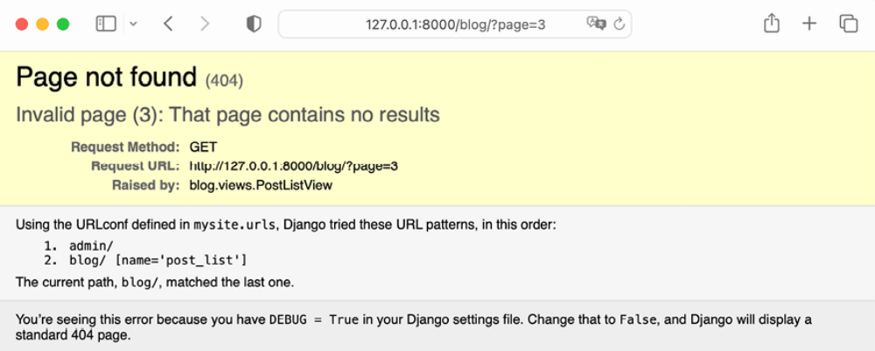
Figure 2.10: HTTP 404 Page not found response

The exception handling that returns the HTTP 404 status code is provided by the ListView view.

This is a simple example of how to write class-based views. You will learn more about class-based views in Chapter 13, Creating a Content Management System, and successive chapters.

You can read an introduction to class-based views at
https://docs.djangoproject.com/en/5.0/topics/classbased-views/intro/.

After learning how to use class-based views and using built-in object pagination, we will implement the functionality for sharing posts by email to engage your blog readers.

Recommending posts by email
We will allow users to share blog posts with others by sending post recommendations via email. You will learn how to create forms in Django, handle data submission, and send emails with Django, enhancing your blog with a personal touch.

Take a minute to think about how you could use views, URLs, and templates to create this functionality using what you learned in the preceding chapter.

To allow users to share posts via email, we will need to:
1. Create a form for users to fill in their name, their email address, the
recipient’s email address, and optional comments
2. Create a view in the views.py file that handles the posted data and
sends the email
3. Add a URL pattern for the new view in the urls.py file of the blog
application
4. Create a template to display the form

Creating forms with Django
Let’s start by building the form to share posts. Django has a built-in forms framework that allows you to create forms easily. The forms framework makes it simple to define the fields of the form, specify how they have to be displayed, and indicate how they have to validate input data. The Django forms framework offers a flexible way to render forms in HTML and handle data.

Django comes with two base classes to build forms:

- Form : This allows you to build standard forms by defining fields and validations.

- ModelForm : This allows you to build forms tied to model instances. It provides all the functionalities of the base Form class, but form fields can be explicitly declared, or automatically generated, from model fields. The form can be used to create or edit model instances.

First, create a forms.py file inside the directory of your blog application and add the following code to it:
from django import forms

class EmailPostForm(forms.Form):
name = forms.CharField(max_length=25)
email = forms.EmailField()
to = forms.EmailField()
comments = forms.CharField(
required = False,
widget = forms.Textarea
)
We have defined our first Django form. The EmailPostForm form inherits from the base Form class. We use different field types to validate data accordingly.
Forms can reside anywhere in your Django project. The
convention is to place them inside a forms.py file for each
application.


The form contains the following fields:

- name : An instance of CharField with a maximum length of 25 characters. We will use it for the name of the person sending the post.

- email : An instance of EmailField . We will use the email of the person sending the post recommendation.

- to : An instance of EmailField . We will use the email address of the recipient, who will receive an email recommending the post.

- comments : An instance of CharField . We will use it for comments to include in the post recommendation email. We have made this field optional by setting required to False , and we have specified a custom widget to render the field.

Each field type has a default widget that determines how the field is rendered in HTML. The name field is an instance of CharField . This type of field is rendered as an <input type="text"> HTML element. The default widget can be overridden with the widget attribute. In the comments field, we use the Textarea widget to display it as a <textarea> HTML element instead of the default <input> element.

Field validation also depends on the field type. For example, the email and to fields are EmailField fields. Both fields require a valid email address; the field validation will otherwise raise a forms.ValidationError exception and the form will not validate. Other parameters are also taken into account for the form field validation, such as the name field having a maximum length of 25 or the comments field being optional.

These are only some of the field types that Django provides for forms. You can find a list of all field types available at https://docs.djangoproject.com/en/5.0/ref/forms/fields/.

Handling forms in views
We have defined the form to recommend posts via email. Now, we need a view to create an instance of the form and handle the form submission.

Edit the views.py file of the blog application and add the following code to it:
from .forms import EmailPostForm

# Create your views here.
def post_share(request, post_id):
# Retrive post by id
Post = get_object_or_404(
Post,
id = post_id,
status = Post.Status.PUBLISHED
)
if request.method=='POST':
# Form was submitted
form = EmailPostForm(request.POST)
if form.is_valid():
# Form fields passed validation
cd = form.cleaned_data
# ...send email
else:
form = EmailPostForm()
return render(
request,
'blog/post/share.html',
{ 'post': post, 'form': form }
)

We have defined the post_share view that takes the request object and the post_id variable as parameters. We use the get_object_or_404() shortcut to retrieve a published post by its id .

We use the same view both for displaying the initial form and processing the submitted data. The HTTP request method allows us to differentiate whether the form is being submitted. A GET request will indicate that an empty form has to be displayed to the user and a POST request will indicate the form is being submitted. We use request.method == 'POST' to differentiate between the two scenarios.
This is the process to display the form and handle the form submission:

1. When the page is loaded for the first time, the view receives a GET
request. In this case, a new EmailPostForm instance is created and
stored in the form variable. This form instance will be used to display
the empty form in the template: form = EmailPostForm()

2. When the user fills in the form and submits it via POST , a form instance
is created using the submitted data contained in request.POST :
if request.method == 'POST':
# Form was submitted
form = EmailPostForm(request.POST)

3. After this, the data submitted is validated using the form’s is_valid()
method. This method validates the data introduced in the form and
returns True if all fields contain valid data. If any field contains invalid
data, then is_valid() returns False . The list of validation errors can be
obtained with form.errors .

4. If the form is not valid, the form is rendered in the template again,
including the data submitted. Validation errors will be displayed in the
template.

5. If the form is valid, the validated data is retrieved with
form.cleaned_data . This attribute is a dictionary of form fields and
their values. Forms not only validate the data but also clean the data by
normalizing it to a consistent format.


If your form data does not validate, cleaned_data will contain only the valid fields.

We have implemented the view to display the form and handle the form submission. We will now learn how to send emails using Django and then we will add that functionality to the post_share view.

Sending emails with Django
Sending emails with Django is very straightforward. You need to have a local SMTP server, or you need to access an external SMTP server, like your email service provider.
The following settings allow you to define the SMTP configuration to send
emails with Django:
- EMAIL_HOST : The SMTP server host; the default is localhost
- EMAIL_PORT : The SMTP port; the default is 25
- EMAIL_HOST_USER : The username for the SMTP server
- EMAIL_HOST_PASSWORD : The password for the SMTP server
- EMAIL_USE_TLS : Whether to use a Transport Layer Security (TLS) secure connection
- EMAIL_USE_SSL : Whether to use an implicit TLS secure connection

Additionally, you can use the DEFAULT_FROM_EMAIL setting to specify the default sender when sending emails with Django. For this example, we will use Google’s SMTP server with a standard Gmail account.

Working with environment variables
We will add SMTP configuration settings to the project, and we will load the SMTP credentials from environment variables. By using environment variables, we will avoid embedding credentials in the source code. There are multiple reasons to keep configuration separate from the code:

- Security: Credentials or secret keys in the code can lead to unintentional exposure, especially if you push the code to public repositories.

- Flexibility: Keeping the configuration separate will allow you to use the same code base across different environments without any changes. You will learn how to build multiple environments in Chapter 17, Going Live.

- Maintainability: Changing a configuration won’t require a code change, ensuring that your project remains consistent across versions.

To facilitate the separation of configuration from code, we are going to use
python-decouple. This library simplifies the use of environment variables in your projects. You can find information about python-decouple at https://github.com/HBNetwork/python-decouple.
First, install python-decouple via pip by running the following command:
python -m pip install python-decouple==3.8

Then, create a new file inside your project’s root directory and name it .env . The .env file will contain key-value pairs of environment variables. Add the following lines to the new file:
EMAIL_HOST_USER=your_account@gmail.com
EMAIL_HOST_PASSWORD=
DEFAULT_FROM_EMAIL=My Blog <your_account@gmail.com>

If you have a Gmail account, replace your_account@gmail.com with your Gmail account. The EMAIL_HOST_PASSWORD variable has no value yet, we will add it later. The DEFAULT_FROM_EMAIL variable will be used to specify the default sender for our emails. If you don’t have a Gmail account, you can use the SMTP credentials for your email service provider.
If you are using a git repository for your code, make sure to include .env in the .gitignore file of your repository. By doing so, you ensure that credentials are excluded from the repository.

Edit the settings.py file of your project and add the following code to it:
from pathlib import Path
from decouple import config
# Email server configuration
EMAIL_HOST = 'smtp.gmail.com'
EMAIL_HOST_USER = config('EMAIL_HOST_USER')
EMAIL_HOST_PASSWORD = config('EMAIL_HOST_PASSWORD')
EMAIL_PORT = 587
EMAIL_USE_TLS = True
DEFAULT_FROM_EMAIL = config('DEFAULT_FROM_EMAIL')

The EMAIL_HOST_USER , EMAIL_HOST_PASSWORD and DEFAULT_FROM_EMAIL settings are now loaded from environment variables defined in the .env file. The provided EMAIL_HOST , EMAIL_PORT and EMAIL_USE_TLS settings are for Gmail’s SMTP server. If you don’t have a Gmail account, you can use the SMTP server configuration of your email service provider.

Instead of Gmail, you can also use a professional, scalable email service that allows you to send emails via SMTP using your own domain, such as SendGrid (https://sendgrid.com/) or Amazon Simple Email Service (SES) (https://aws.amazon.com/ses/). Both services will require you to verify your domain and sender email accounts and will provide you with SMTP credentials to send emails. The django-anymail application simplifies the task of adding email service providers to your
project like SendGrid or Amazon SES. You can find installation instructions for django-anymail at
https://anymail.dev/en/stable/installation/, and the list of supported email service providers at https://anymail.dev/en/stable/esps/.

If you can’t use an SMTP server, you can tell Django to write emails to the console by adding the following setting to the settings.py file: (just after the email configuration)
DEFAULT_FROM_EMAIL = config('DEFAULT_FROM_EMAIL')

By using this setting, Django will output all emails to the shell instead of sending them. This is very useful for testing your application without an SMTP server.

In order to send emails with Gmail’s SMTP server, make sure that two-step verification is active in your Gmail account.

Open https://myaccount.google.com/security in your browser and enable 2-Step Verification for your account, as shown in Figure 2.11:
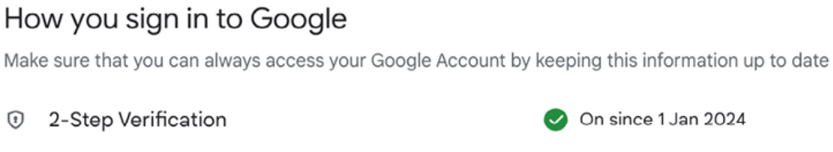
2.11: The sign in to Google page for Google accounts

Then, you need to Figure create an app password and use it for your SMTP credentials. An app password is a 16-digit passcode that gives a less secure app or device permission to access your Google account.

To create an app password, open
https://myaccount.google.com/apppasswords in your browser. You will see the following screen:
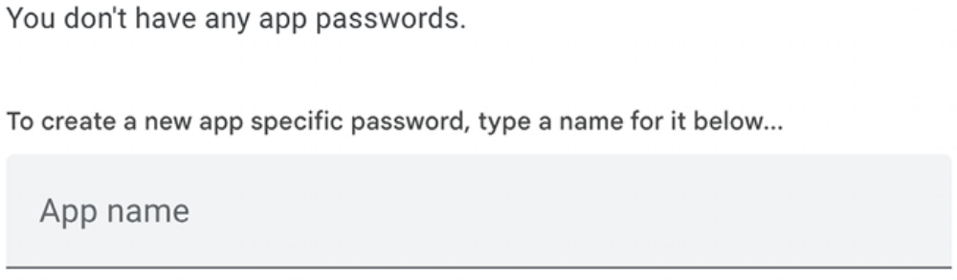
Figure 2.12: Form to generate a new Google app password

If you cannot access App passwords, it might be that 2-Step Verification is not set for your account, your account is an organization account instead of a standard Gmail account, or you turned on Google’s advanced protection.

Make sure to use a standard Gmail account and activate 2-Step Verification for your Google account. You can find more information at https://support.google.com/accounts/answer/185833.

Enter the name Blog and click the Create button, as follows:
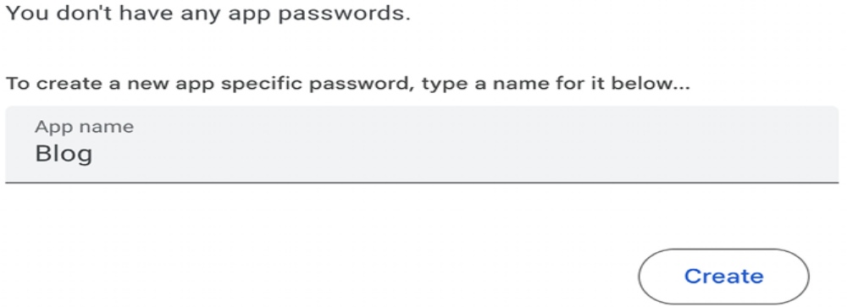
Figure 2.13: Form to generate a new Google app password
A new password will be generated and displayed like this:
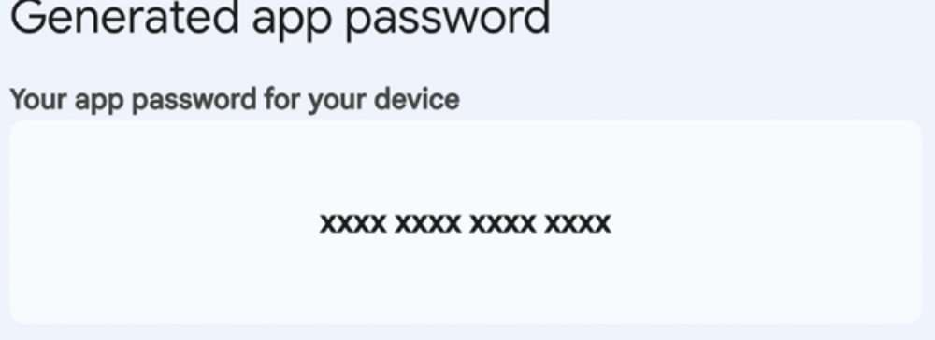
Figure 2.14: Generated Google app password

Copy the generated app password.

Next, edit the .env file of your project and add the app password to the
EMAIL_HOST_PASSWORD variable, as follows:
EMAIL_HOST_USER=your_account@gmail.com
EMAIL_HOST_PASSWORD=xxxxxxxxxxxxxxxx
DEFAULT_FROM_EMAIL=My Blog <your_account@gmail.com>

Open the Python shell by running the following command in the system shell prompt:
python manage.py shell

Execute the following code in the Python shell:
>>> from django.core.mail import send_mail
>>> send_mail('Django mail',
... 'This e-mail was sent with Django.',
... 'your_account@gmail.com',
... ['your_account@gmail.com'],
... fail_silently=False)

The send_mail() function takes the subject, message, sender, and list of recipients as required arguments. By setting the optional argument fail_silently=False , we are telling it to raise an exception if the email cannot be sent. If the output you see is 1 , then your email was successfully sent.

If you get a CERTIFICATE_VERIFY_FAILED error, install the certify module with the command pip install --upgrade certifi . If you are using macOS, run the following command on the shell to install certify and let Python access macOS root certificates:
/Applications/Python\ 3.12/Install\ Certificates.command

Check your inbox. You should have received the email as displayed in Figure 2.15:
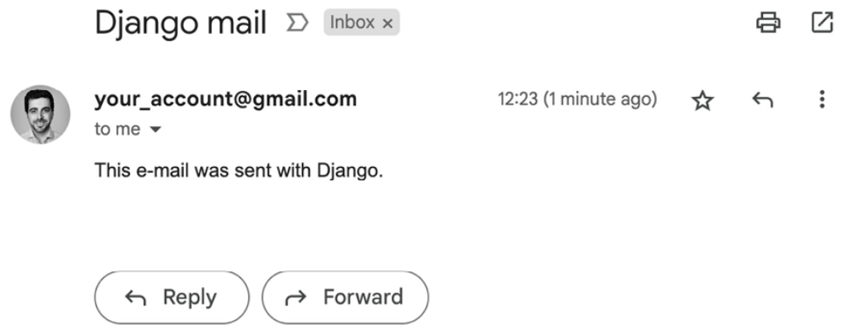
Figure 2.15: Test email sent displayed in Gmail

You just sent your first email with Django! You can find more information about sending emails with Django at https://docs.djangoproject.com/en/5.0/topics/email/.

Let’s add this functionality to the post_share view.

Sending emails in views
Edit the post_share view in the views.py file of the blog application, as
follows:
# …
from django.core.mail import send_mail

# Create your views here.
def post_share(request, post_id):
# Retrive post by id
post = get_object_or_404(
Post,
id = post_id,
status = Post.Status.PUBLISHED
)
sent=False
if request.method=='POST':
# Form was submitted
form = EmailPostForm(request.POST)
if form.is_valid():
# Form fields passed validation
cd = form.cleaned_data
post_url = request.build_absolute_uri(
post.get_absolute_url()
)
subject = (
f"{cd['name']} ({cd['email']})"
f"recommends you read {post.title}"
)
message = (
f"Read {post.title} at {post_url}\n\n"
f"{cd['name']}\'s comments: {cd['comments']}"
)
send_mail(
subject = subject,
message = message,
from_email = None,
recipient_list = [cd['to']]
)
sent = True
else:
form = EmailPostForm()
return render(
request,
'blog/post/share.html',
{'post': post, 'form': form, 'sent':sent}
)

In the preceding code, we have declared a sent variable with the initial False value. We set this variable to True after the email is sent. We will use the sent variable later in the template to display a success message when the form is successfully submitted.

Since we have to include a link to the post in the email, we retrieve the absolute path of the post using its get_absolute_url() method. We use this path as an input for request.build_absolute_uri() to build a complete URL, including the HTTP schema and hostname.

We create the subject and the message body of the email using the cleaned data of the validated form. Finally, we send the email to the email address contained in the to field of the form. In the from_email parameter, we pass the None value, so the value of the DEFAULT_FROM_EMAIL setting will be used for the sender.

Now that the view is complete, we have to add a new URL pattern for it.

Open the urls.py file of your blog application and add the post_share
URL pattern, as follows:
from django.urls import path
from . import views

app_name = 'blog'
urlpatterns = [
# Post views
path('', views.PostListView.as_view(), name='post_list'),
path('<int:year>/<int:month>/<int:day>/<slug:post>/',
views.post_detail, name='post_detail'),
path('<int:post_id>/share/', views.post_share, name='post_share'),
]

Rendering forms in templates
After creating the form, programming the view, and adding the URL pattern, the only thing missing is the template for the view.

Create a new file in the blog/templates/blog/post/ directory and name it share.html .

Add the following code to the new share.html template:
{% extends "blog/base.html" %}
{% block title %}Share a post{% endblock %}
{% block content %}

{% if sent %}
<h1>E-mail successfully sent</h1>
<p>"{{ post.title }}" was successfully sent to {{ form.cleaned_data.to }}.
</p>
{% else %}
<h1>Share "{{ post.title }}" by e-mail</h1>
<form method="post">
{{ form.as_p }}
{% csrf_token %}
<input type="submit" value="Send e-mail">
</form>
{% endif %}
{% endblock %}

This is the template that is used to both display the form to share a post via email and to display a success message when the email has been sent. We differentiate between both cases with {% if sent %} .

To display the form, we have defined an HTML form element, indicating that it has to be submitted by the POST method:
<form method="post">

We have included the form instance with {{ form.as_p }} . We tell Django to render the form fields using HTML paragraph <p> elements by using the as_p method. We could also render the form as an unordered list with as_ul or as an HTML table with as_table .

We have added a {% csrf_token %} template tag. This tag introduces a hidden field with an autogenerated token to avoid cross-site request forgery (CSRF) attacks. These attacks consist of a malicious website or program performing an unwanted action for a user on the site. You can find more information about CSRF at https://owasp.org/wwwcommunity/attacks/csrf.

The {% csrf_token %} template tag generates a hidden field that is rendered like this:
<input type='hidden' name='csrfmiddlewaretoken' value='26JjKo2lc


By default, Django checks for the CSRF token in all POST
requests. Remember to include the csrf_token tag in all
forms that are submitted via POST .

Edit the blog/post/detail.html template and make it look like this:
{% extends "blog/base.html" %}
{% block title %}{{ post.title }}{% endblock %}
{% block content %}
<h1>{{ post.title }}</h1>
<p class="date">
Publidhed {{ post.publish }} by {{ post.author }}
</p>
{{ post.body|linebreaks }}
<p>
<a href="{% url "blog:post_share" post.id %}">
Share this post
</a>
</p>
{% endblock %}

We have added a link to the post_share URL. The URL is built dynamically with the {% url %} template tag provided by Django. We use the namespace called blog and the URL named post_share . We pass the id post as a parameter to build the URL.

Open the shell prompt and execute the following command to start the development server:
python manage.py runserver

Open http://127.0.0.1:8000/blog/ in your browser and click on any post title to view the post detail page.

Under the post body, you should see the link that you just added, as shown in Figure 2.16:

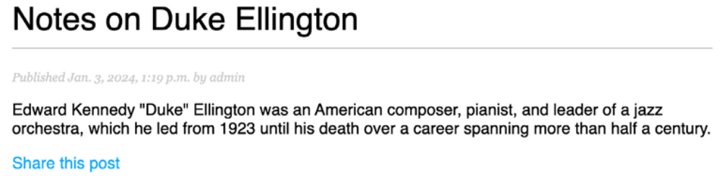
Figure 2.16: The post detail page, including a link to share the post

Click on Share this post, and you should see the page, including the form to share this post by email, as follows:
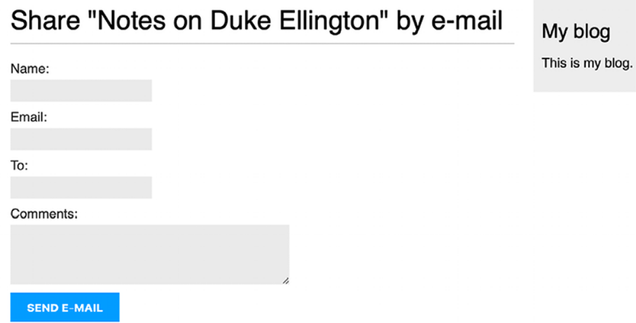
Figure 2.17: The page to share a post via email

CSS styles for the form are included in the example code in the static/css/blog.css file. When you click on the SEND E-MAIL button, the form is submitted and validated. If all fields contain valid data, you get a success message, as follows:
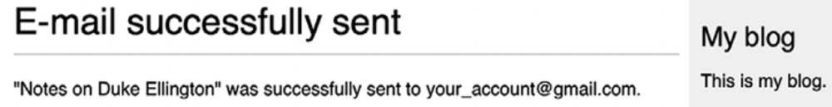
Figure 2.18: A success message for a post shared via email

Send a post to your own email address and check your inbox. The email you receive should look like this:
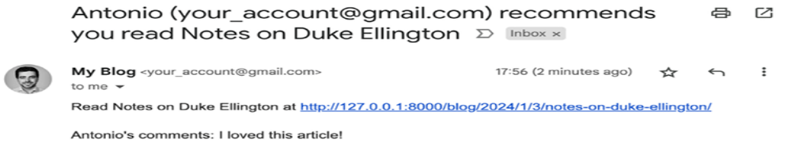
Figure 2.19: Test email sent displayed in Gmail
If you submit the form with invalid data, the form will be rendered again, including all validation errors:
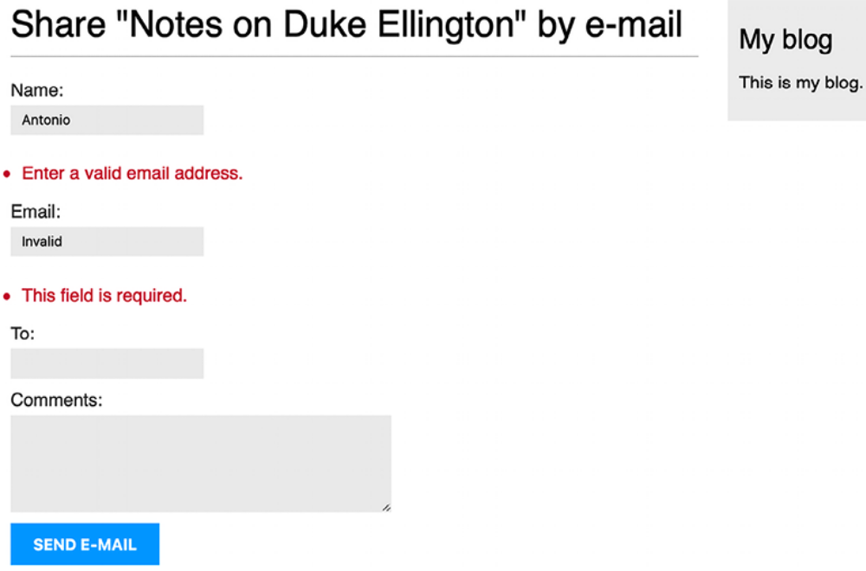
Figure 2.20: The share post form displaying invalid data errors

Most modern browsers will prevent you from submitting a form with empty or erroneous fields. This is because the browser validates the fields based on their attributes before submitting the form. In this case, the form won’t be submitted, and the browser will display an error message for the fields that are wrong. To test the Django form validation using a modern browser, you can skip the browser form validation by adding the novalidate attribute to the HTML <form> element, like <form method="post" novalidate> . You can add this attribute to prevent the browser from validating fields and test your own form validation. After you are done testing, remove the novalidate attribute to keep the browser form validation.

The functionality for sharing posts by email is now complete. You can find more information about working with forms at https://docs.djangoproject.com/en/5.0/topics/forms/.

Creating a comment system
We will continue extending our blog application with a comment system that will allow users to comment on posts. To build the comment system, we will need the following:

- A comment model to store user comments on posts

- A Django form that allows users to submit comments and manages the data validation

- A view that processes the form and saves a new comment to the database

- A list of comments and the HTML form to add a new comment that can be included in the post detail template

Creating a model for comments
Let’s start by building a model to store user comments on posts.

Open the models.py file of your blog application and add the following
code:
class Comment(models.Model):
post = models.ForeignKey(
Post,
on_delete = models.CASCADE,
related_name = 'comments'
)
name = models.CharField(max_length=80)
email = models.EmailField()
body = models.TextField()
created = models.DateTimeField(auto_now_add=True)
updeated = models.DateTimeField(auto_now=True)
active = models.BooleanField(default=True)
class Meta:
ordering = ['created']
indexes = [models.index(fields=['created'])]
def __str__(self):
return f'Comment by {self.name} on {self.post}'

This is the Comment model. We have added a ForeignKey field to associate each comment with a single post. This many-to-one relationship is defined in the Comment model because each comment will be made on one post, and each post may have multiple comments.

The related_name attribute allows you to name the attribute that you use for the relationship from the related object back to this one. We can retrieve the post of a comment object using comment.post and retrieve all comments associated with a post object using post.comments.all() . If you don’t define the related_name attribute, Django will use the name of the model in lowercase, followed by _set (that is, comment_set ) to name the relationship of the related object to the object of the model, where this relationship has
been defined.

You can learn more about many-to-one relationships at
https://docs.djangoproject.com/en/5.0/topics/db/examples/many_to_one/.

We have defined the active Boolean field to control the status of the comments. This field will allow us to manually deactivate inappropriate comments using the administration site. We use default=True to indicate that all comments are active by default.

We have defined the created field to store the date and time when the comment was created. By using auto_now_add , the date will be saved automatically when creating an object. In the Meta class of the model, we have added ordering = ['created'] to sort comments in chronological order by default, and we have added an index for the created field in
ascending order. This will improve the performance of database lookups or ordering results using the created field.

The Comment model that we have built is not synchronized with the database. We need to generate a new database migration to create the corresponding database table.

Run the following command from the shell prompt:
python manage.py makemigrations blog

You should see the following output:
Migrations for 'blog':
blog/migrations/0003_comment.py
- Create model Comment

Django has generated a 0003_comment.py file inside the migrations/ directory of the blog application. We need to create the related database schema and apply the changes to the database.

Run the following command to apply existing migrations:
python manage.py migrate

You will get an output that includes the following line:
Applying blog.0003_comment... OK

The migration has been applied and the blog_comment table has been created in the database.

Adding comments to the administration site
Next, we will add the new model to the administration site to manage comments through a simple interface.

Open the admin.py file of the blog application, import the Comment model, and add the following ModelAdmin class:
from .models import Comment, Post
# Register your models here.
@admin.register(Comment)
class CommentAdmin(admin.ModelAdmin):
list_display = ['name', 'email', 'post','created', 'active']
list_filter = ['active', 'created', 'updated']
search_fields = ['name', 'email', 'body']

Open the shell prompt and execute the following command to start the development server:
python manage.py runserver

Open http://127.0.0.1:8000/admin/ in your browser. You should see the new model included in the BLOG section, as shown in Figure 2.21:
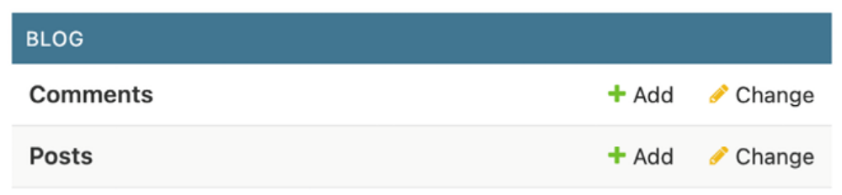
Figure 2.21: Blog application models on the Django administration index page

The model is now registered on the administration site. In the Comments row, click on Add. You will see the form to add a new comment:
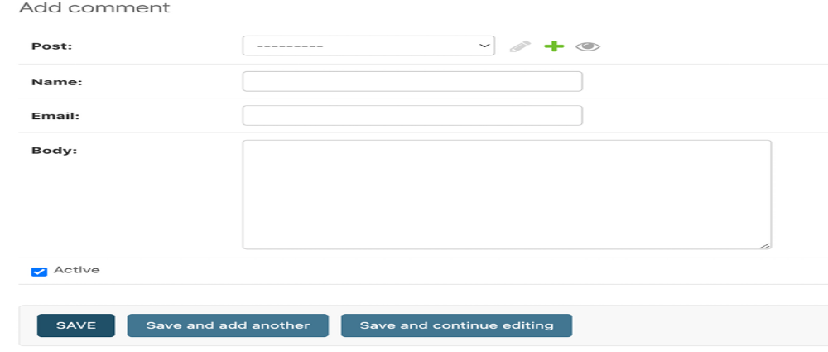
Figure 2.22: Form to add a new comment in the Django administration site

Now we can manage Comment instances using the administration site.

Creating forms from models
We need to build a form to let users comment on blog posts. Remember that Django has two base classes that can be used to create forms: Form and ModelForm . We used the Form class to allow users to share posts by email. Now, we will use ModelForm to take advantage of the existing Comment model and build a form dynamically for it.

Edit the forms.py file of your blog application and add the following lines:
from .models import Comment

class CommentForm(forms.ModelForm):
class Meta:
models = Comment
fields = ['name', 'email', 'body']

To create a form from a model, we just indicate which model to build the form for in the Meta class of the form. Django will introspect the model and build the corresponding form dynamically.

Each model field type has a corresponding default form field type. The attributes of model fields are taken into account for form validation. By default, Django creates a form field for each field contained in the model. However, we can explicitly tell Django which fields to include in the form using the fields attribute or define which fields to exclude using the exclude attribute. In the CommentForm form, we have explicitly included the name , email , and body fields. These are the only fields that will be included in the form.

You can find more information about creating forms from models at
https://docs.djangoproject.com/en/5.0/topics/forms/modelforms/.

Handling ModelForms in views
For sharing posts by email, we used the same view to display the form and manage its submission. We used the HTTP method to differentiate between both cases: GET to display the form and POST to submit it. In this case, we will add the comment form to the post detail page, and we will build a separate view to handle the form submission. The new view that processes the form will allow the user to return to the post detail view once the comment has been stored in the database.

Edit the views.py file of the blog application and add the following code:
from django.core.paginator import EmptyPage, Paginator
from django.shortcuts import get_object_or_404, render
from django.core.mail import send_mail
from django.views.generic import ListView
from django.views.decorators.http import require_POST
from .forms import EmailPostForm, CommentForm
from .models import Post
#...

@require_POST
def post_comment(request, post_id):
post = get_object_or_404(
Post,
id = post_id,
status = Post.Status.PUBLISHED
)
comment = None
# A comment was posted
form = CommentForm(data=request.POST)
if form.is_valid():
# Create a Comment object without saving
# it to the database
comment = form.save(commit=False)
# Assign the post to the comment
comment.post = post
# Save the comment to the database
comment.save()
return render(
request,
'blog/post/comment.html',
{
'post':post,
'form':form,
'comment':comment
}
)
We have defined the post_comment view that takes the request object and the post_id variable as parameters. We will be using this view to manage the post submission. We expect the form to be submitted using the HTTP POST method. We use the require_POST decorator provided by Django to only allow POST requests for this view. Django allows you to restrict the HTTP methods allowed for views. Django will throw an HTTP 405 (method
not allowed) error if you try to access the view with any other HTTP method.

In this view, we have implemented the following actions:
1. We retrieve a published post by its id using the get_object_or_404() shortcut.

2. We define a comment variable with the initial value None . This variable will be used to store the comment object when it is created.

3. We instantiate the form using the submitted POST data and validate it using the is_valid() method. If the form is invalid, the template is rendered with the validation errors.

4. If the form is valid, we create a new Comment object by calling the form’s save() method and assign it to the comment variable, as follows: comment = form.save(commit=False)

5. The save() method creates an instance of the model that the form is linked to and saves it to the database. If you call it using commit=False , the model instance is created but not saved to the database. This allows us to modify the object before finally saving it.
The save() method is available for ModelForm but not
for Form instances since they are not linked to any
model.

6. We assign the post to the comment we created:
comment.post = post

7. We save the new comment to the database by calling its save() method:
comment.save()

8. We render the blog/post/comment.html template, passing the post , form , and comment objects in the template context. This template doesn’t exist yet; we will create it later.

Let’s create a URL pattern for this view.

Edit the urls.py file of the blog application and add the following URL pattern to it:
from django.urls import path
from . import views

app_name = 'blog'
urlpatterns = [
# Post views
path('', views.PostListView.as_view(), name='post_list'),
path('<int:year>/<int:month>/<int:day>/<slug:post>/',
views.post_detail, name='post_detail'),
path('<int:post_id>/share/', views.post_share, name='post_share'),
path('<int:post_id>/share/', views.post_comment, name='post_'),
]

We have implemented the view to manage the submission of comments and their corresponding URL. Let’s create the necessary templates.

Creating templates for the comment form
We will create a template for the comment form that we will use in two places:

- In the post detail template associated with the post_detail view to let users publish comments.

- In the post comment template associated with the post_comment view to display the form again if there are any form errors.

We will create the form template and use the {% include %} template tag to include it in the two other templates.

In the templates/blog/post/ directory, create a new includes/ directory. Add a new file inside this directory and name it comment_form.html .

The file structure should look as follows:
templates/
blog/
post/
includes/
comment_form.html
detail.html
list.html
share.html

Edit the new blog/post/includes/comment_form.html template and add the following code:
<h2>Add a new comment</h2>
{% if form.errors %}
<div class="errors">
{{ form.errors }}
</div>
{% endif %}
<form action="{% url 'blog:post_comment' post.id %}" method="post">
{{ form.as_p }}
{% csrf_token %}
<p><input type="submit" value="Add comment"></p>
</form>

In this template, we build the action URL of the HTML <form> element dynamically using the {% url %} template tag. We build the URL of the post_comment view that will process the form. We display the form rendered in paragraphs and we include {% csrf_token %} for CSRF protection because this form will be submitted with the POST method.

Create a new file in the templates/blog/post/ directory of the blog application and name it comment.html .

The file structure should now look as follows:
templates/
blog/
post/
includes/
comment_form.html
comment.html
detail.html
list.html
share.html

Edit the new blog/post/comment.html template and add the following code:
{% extends "blog/base.html" %}
{% block title %}Add a comment{% endblock %}
{% block content %}
{% if comment %}
<h2>Your comment has been added.</h2>
<p><a href="{{ post.get_absolute_url }}">Back to the post</a></p>
{% else %}
{% include "blog/post/includes/comment_form.html" %}
{% endif %}
{% endblock %}

This is the template for the post comment view. In this view, we expect the form to be submitted via the POST method. The template covers two different scenarios:

- If the form data submitted is valid, the comment variable will contain the comment object that was created and a success message will be displayed.

- If the form data submitted is not valid, the comment variable will be None . In this case, we will display the comment form. We use the {% include %} template tag to include the comment_form.html template that we have previously created.

Adding comments to the post detail view
To complete the comment functionality, we will add the list of comments and the comment form to the post_detail view.

Edit the views.py file of the blog application and edit the post_detail view as follows:
def post_detail(request, year, month, day, post):
post = get_object_or_404(
Post,
status = Post.Status.PUBLISHED,
slug = post,
publish__year=year,
publish__month=month,
publish__day=day
)
# List of active comments for this post
comments = post.comments.filter(active=True)
# Form for users to comment
form = CommentForm()
return render(
request,
'blog/post/detail.html',
{'post':post,
'comments':comments,
'form':form}
)

- Let’s review the code we have added to the post_detail view: We have added a QuerySet to retrieve all active comments for the post, as follows:
comments = post.comments.filter(active=True)

- This QuerySet is built using the post object. Instead of building a QuerySet for the Comment model directly, we leverage the post object to retrieve the related Comment objects. We use the comments manager for the related Comment objects that we previously defined in the Comment model, using the related_name attribute of the ForeignKey field to the Post model.

- We have also created an instance of the comment form with form = CommentForm() .

Adding comments to the post detail template
We need to edit the blog/post/detail.html template to implement the following:

- Display the total number of comments for a post

- Display the list of comments

- Display the form for users to add a new comment

We will start by adding the total number of comments for a post.

Edit the blog/post/detail.html template and change it as follows:
{% extends "blog/base.html" %}
{% block title %}{{ post.title }}{% endblock %}
{% block content %}
<h1>{{ post.title }}</h1>
<p class="date">
Publidhed {{ post.publish }} by {{ post.author }}
</p>
{{ post.body|linebreaks }}
<p>
<a href="{% url 'blog:post_share' post.id %}">
Share this post
</a>
</p>
{% with comments.count as total_comments %}
<h2>
{{ total_comments }} comment{{total_comments|pluralize }}
</h2>
{% endwith %}
{% endblock %}

We use the Django object relational mapper (ORM) in the template, executing the comments.count() QuerySet. Note that the Django template language doesn’t use parentheses for calling methods. The {% with %} tag allows you to assign a value to a new variable that will be available in the template until the {% endwith %} tag.
The {% with %} template tag is useful for avoiding hitting
the database or accessing expensive methods multiple times.

We use the pluralize template filter to display a plural suffix for the word “comment,” depending on the total_comments value. Template filters take the value of the variable they are applied to as their input and return a computed value. We will learn more about template filters in Chapter 3, Extending Your Blog Application.

The pluralize template filter returns a string with the letter “s” if the value is different from 1 . The preceding text will be rendered as 0 comments, 1 comment, or N comments, depending on the number of active comments for the post.

Now, let’s add the list of active comments to the post detail template.

Edit the blog/post/detail.html template and implement the following changes:
{% extends "blog/base.html" %}
{% block title %}{{ post.title }}{% endblock %}
{% block content %}
<h1>{{ post.title }}</h1>
<p class="date">
Publidhed {{ post.publish }} by {{ post.author }}
</p>
{{ post.body|linebreaks }}
<p>
<a href="{% url 'blog:post_share' post.id %}">
Share this post
</a>
</p>
{% with comments.count as total_comments %}
<h2>
{{ total_comments }} comment{{total_comments|pluralize }}
</h2>
{% endwith %}
{% for comment in comments %}
<div class="comment">
<p class="info">
Comment {{ forloop.counter }} by {{ comment.name }}
{{ comment.created }}
</p>
{{ comment.body|linebreaks }}
</div>
{% empty %}
<p>There are no comments.</p>
{% endfor %}
{% endblock %}

We have added a {% for %} template tag to loop through the post comments. If the comments list is empty, we display a message that informs users that there are no comments for this post. We enumerate comments with the {{ forloop.counter }} variable, which contains the loop counter in each iteration. For each post, we display the name of the user who posted it, the date, and the body of the comment.

Finally, let’s add the comment form to the template.

Edit the blog/post/detail.html template and include the comment form
template as follows:
{% extends "blog/base.html" %}
{% block title %}{{ post.title }}{% endblock %}
{% block content %}
<h1>{{ post.title }}</h1>
<p class="date">
Publidhed {{ post.publish }} by {{ post.author }}
</p>
{{ post.body|linebreaks }}
<p>
<a href="{% url 'blog:post_share' post.id %}">
Share this post
</a>
</p>
{% with comments.count as total_comments %}
<h2>
{{ total_comments }} comment{{total_comments|pluralize }}
</h2>
{% endwith %}
{% for comment in comments %}
<div class="comment">
<p class="info">
Comment {{ forloop.counter }} by {{ comment.name }}
{{ comment.created }}
</p>
{{ comment.body|linebreaks }}
</div>
{% empty %}
<p>There are no comments.</p>
{% endfor %}
{% include "blog/post/includes/comment_form.html" %}
{% endblock %}

Open http://127.0.0.1:8000/blog/ in your browser and click on a post
title to take a look at the post detail page. You will see something like Figure 2.23:
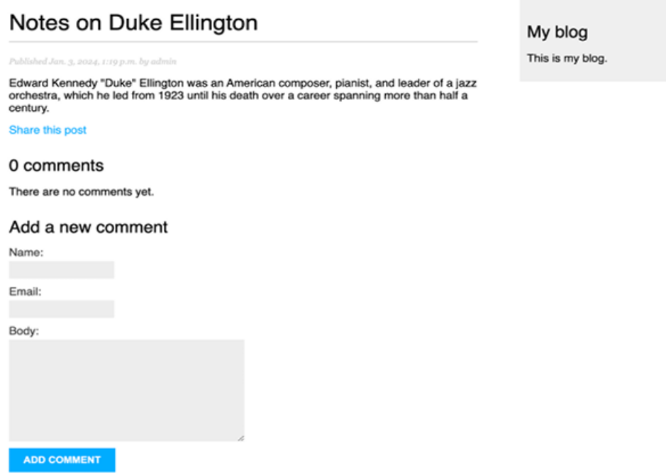
Figure 2.23: The post detail page, including the form to add a comment

Fill in the comment form with valid data and click on Add comment. You should see the following page:

Figure 2.24: The comment added success page

Click on the Back to the post link. You should be redirected back to the post detail page, and you should be able to see the comment that you just added, as follows:
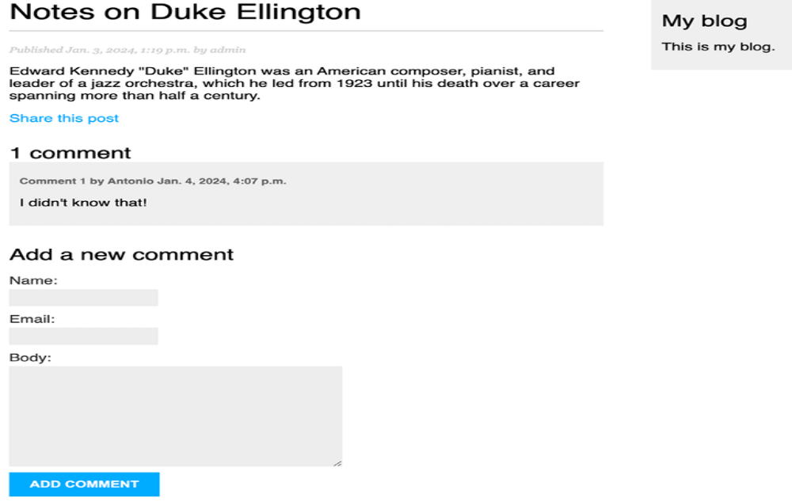
Figure 2.25: The post detail page, including a comment
Add one more comment to the post. The comments should appear below the post contents in chronological order, as follows:
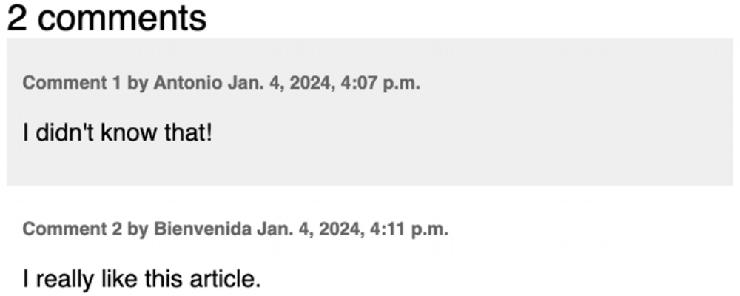
Figure 2.26: The comment list on the post detail page

Open http://127.0.0.1:8000/admin/blog/comment/ in your browser. You will see the administration page with the list of comments you created, like this:
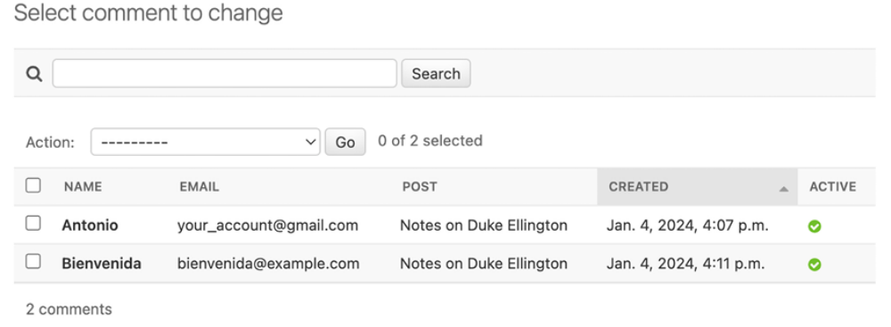
Figure 2.27: List of comments on the administration site

Click on the name of one of the posts to edit it. Uncheck the Active checkbox as follows and click on the Save button:
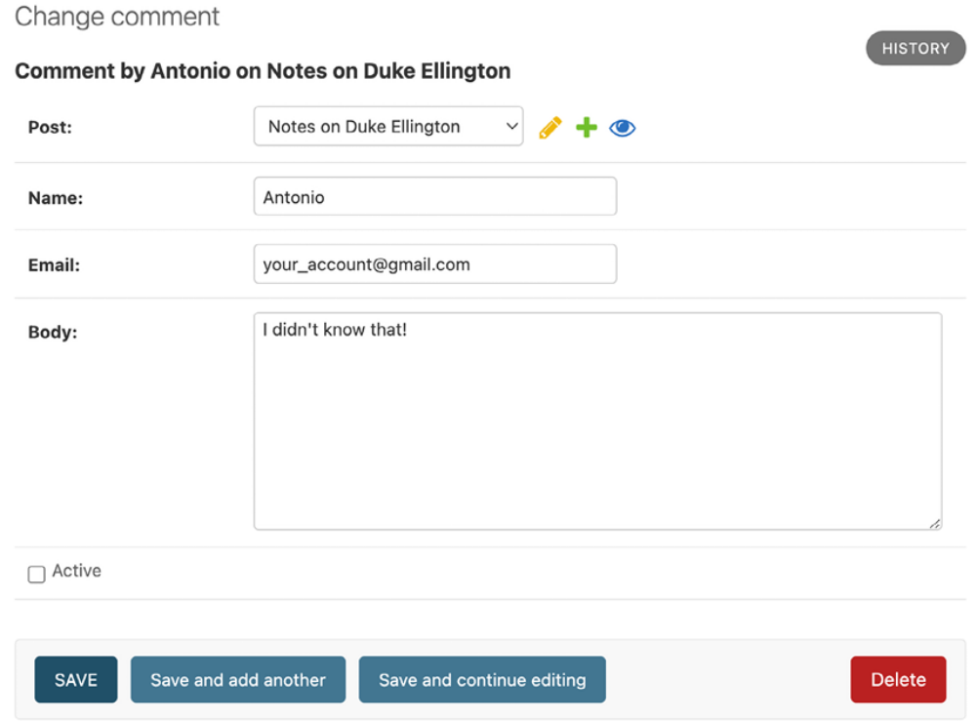
Figure 2.28: Editing a comment on the administration site

You will be redirected to the list of comments. The Active column will display an inactive icon for the comment, as shown in Figure 2.29:
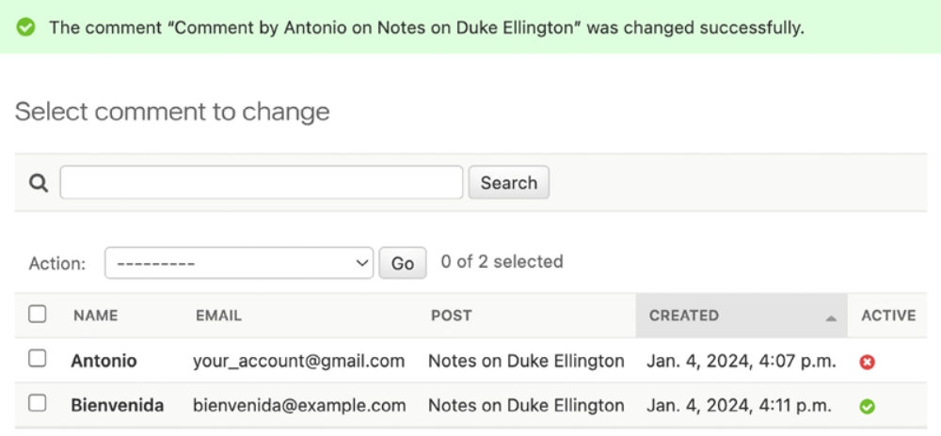
Figure 2.29: Active/inactive comments on the administration site

If you return to the post detail view, you will note that the inactive comment is no longer displayed, neither is it counted for the total number of active comments for the post:
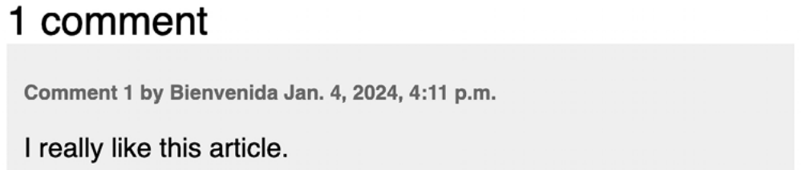
Figure 2.30: A single active comment displayed on the post detail page

Thanks to the active field, you can deactivate inappropriate comments and avoid showing them on your posts.

Using simplified templates for form rendering
You have used {{ form.as_p }} to render the forms using HTML paragraphs. This is a very straightforward method for rendering forms, but there may be occasions when you need to employ custom HTML markup for rendering forms.

To use custom HTML for rendering form fields, you can access each form field directly, or iterate through the form fields, as in the following example:
{% for field in form %}
<div class="my-div">
{{ field.errors }}
{{ field.label_tag }} {{ field }}
<div class="help-text">{{ field.help_text|safe }}</div>
</div>
{% endfor %}

In this code, we use {{ field.errors }} to render any field errors of the form, {{ field.label_tag }} to render the form HTML label, {{ field }} to render the actual field, and {{ field.help_text|safe }} to render the field’s help text HTML.

This method is helpful to customize how forms are rendered, but you might need to add certain HTML elements for specific fields or include some fields in containers. Django 5.0 introduces field groups and field group templates. Field groups simplify the rendering of labels, widgets, help texts, and field errors. Let’s use this new feature to customize the comment form.

We are going to use custom HTML markup to reposition the name and email form fields using additional HTML elements.

Edit the blog/post/includes/comment_form.html template and modify it as follows. The new code is highlighted in bold:
<h2>Add a new comment</h2>

{% if form.errors %}
<div class="errors">
{{ form.errors }}
</div>
{% endif %}
<form action="{% url 'blog:post_comment' post.id %}" method="post">
<div class="left">
{{ form.name.label_tag }}<br>
{{ form.name }}
{{ form.name.errors }}
</div>
<div class="left">
{{ form.email.label_tag }}<br>
{{ form.email }}
{{ form.email.errors }}
</div>
<div class="clear">
{{ form.body.label_tag }}<br>
{{ form.body }}
{{ form.body.errors }}
</div>
{% csrf_token %}
<p><input type="submit" value="Add comment"></p>
</form>
We have added <div> containers for the name and email fields with a custom CSS class to float both fields to the left. The as_field_group method renders each field including help text and errors. This method uses the django/forms/field.html template by default. You can see the contents of this template at
https://github.com/django/django/blob/stable/5.0.x/django/forms/templates/django/forms/field.html. You can also create custom field templates and reuse them by adding the template_name attribute to any form field. You can read more about reusable
form templates athttps://docs.djangoproject.com/en/5.0/topics/forms/#reusable-field-group-templates.

Open a blog post and take a look at the comment form. The form should now look like Figure 2.31:
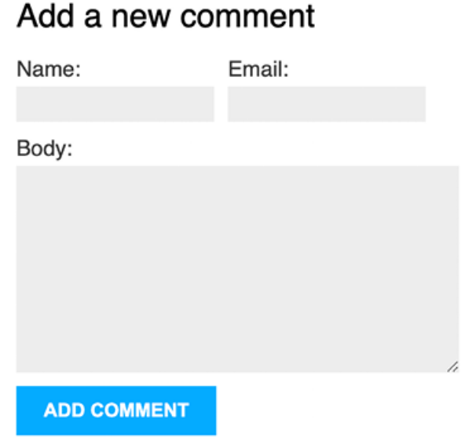
Figure 2.31: The comment form with the new HTML markup

The name and email fields are now displayed next to each other. Field groups allow you to easily customize form rendering.

Summary
In this chapter, you learned how to define canonical URLs for models. You created SEO-friendly URLs for blog posts, and you implemented object pagination for your post list. You also learned how to work with Django forms and model forms. You created a system to recommend posts by email and created a comment system for your blog.

In the next chapter, you will create a tagging system for the blog. You will learn how to build complex QuerySets to retrieve objects by similarity. You will learn how to create custom template tags and filters. You will also build a custom sitemap and feed for your blog posts and implement full-text search functionality for your posts.

Additional resources
The following resources provide additional information related to the topics covered in this chapter:
Source code for this chapter: ( See page 202)

